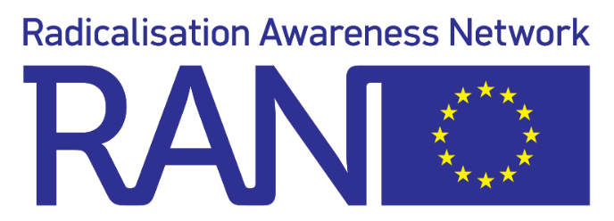
Practitioner Exchange Programme
Application form

Framework conditions
Participants of the Practitioner Exchange Programme are requested to read and agree to the following framework conditions:

General principles

- Exchanges in the Practitioner Exchange Programme are in principle one-on-one exchanges between practitioners. In justified cases, the Commission can raise the number to maximum 3 practitioners visiting each other. In case of the latter, a good gender balance will be taken into account.
- The exchange programme has a flexible nature; if a practitioner hosts another practitioner, he/she can visit either the same practitioner that he/she has hosted, or another practitioner.

Matching principles

- Participants being matched for the programme are not based in the same EU Member State
- Matches are made based on practitioners:
  - who work in the same field;
  - do comparable working activities;
  - share similar responsibilities to make sure that they use the learnings in their day-to-day work;
  - have compatible learning priorities.

Logistical information

- RAN covers the costs for travel and accommodation of the visiting practitioner.
- The duration of the exchanges is up to 5 working days, ideally 3-5 working days. We aim to make this happen in the months September to December 2022.
- Practitioners need to have a mutual language they can communicate in (no interpretation will be provided).
- RAN provides a daily allowance of maximum 50 euros to reimburse costs made for lunch and dinner. The reimbursement upon receipt is subject to the finalisation of the concept note and, if applicable, the assignment.

Commitments by participants

- Before the exchange, the participating practitioners commit to draft, with the support of RAN, a concept note which contains the programme of the exchange and possibly an assignment.
- After the exchange, the practitioners agree to share a written testimony (in English, German or French) to provide feedback on the exchange. This testimony can be included in RAN newsletters and can be disseminated via the RAN communication channels either integrally or via quotes.
- The practitioner might also decide to provide a video or a recorded testimony about the exchange, if desired. This video can be included in RAN newsletters and can be disseminated via the RAN communication channels either integrally or via quotes.
- In addition, RAN Staff will organise an online meeting with all participants of the programme.

Support provided by the RAN

- RAN Staff supports the exchange by
  - matching participants;
  - supporting participants in the drafting of the concept note;
  - providing a contact person during the exchange and back-up contact details;
  - taking care of travel and accommodation.

GDPR regulation
In order to ensure a safe haven in which practitioners can exchange freely, participants are asked to read and agree to the following GDPR conditions.

Privacy notice
In order to manage and communicate about the RAN programme in general and the exchange programme specifically, RAN Staff have to collect and save your personal data. The RAN Privacy Notice (see website) describes RAN’s policies and practices regarding its collection and use of your personal data and sets forth your privacy rights.

Chatham house rule
In all RAN meetings, the Chatham house rule is maintained to encourage openness of discussion and facilitate the sharing of information. Participants of the Practitioner Exchange Programme are requested to agree to this rule. The exchanges should allow participants to feel free to share potential sensitive information. Participants should therefore agree to this rule:
‘When a meeting, or part thereof, is held under the Chatham House Rule, participants are free to use the information received, but neither the identity nor the affiliation of the speaker(s), nor that of any other participant, may be revealed.’

Application form
Please fill in the following table and send a signed copy (both by you and your supervisor) of this document to ran@radareurope.nl.

Name
Gender
Organisation
EU Member State
Job profile
Daily working activities
What expertise can you offer as a hosting practitioner to other practitioners?
Learning objective as a visiting practitioner
Do you already have a peer, city or organisation in mind for the exchange which we can take into account? If yes, which one?
Number of days and periods of availability (max 5 working days)
Languages (B2 level speaking)
Consent to agree and commit to the framework conditions and the Chatman House rule (please specify: “Yes, I consent”)
Consent to the processing of your personal information as per the privacy notice (please specify: “Yes, I consent”)
Telephone number and e-mail
Signature of the practitioner
Signature of the practitioner’s supervisor

